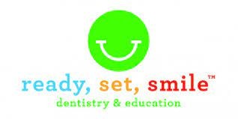
Oral Health Community Health Worker Job Description
Through education and preventive services Ready, Set, Smile prepares and empowers all children in our community to care for their oral health and gives them the opportunity to be free of dental disease.
We’re looking for an energetic, passionate and dedicated person to connect with children, families and schools in our community to empower them to care for their oral health through learning and doing. Too many children have poor oral health that affects their ability to learn and develop in optimal ways. You can be the difference!
CHW’s who join our team will learn from us how to teach children about oral health, develop relationships with families, and nurture partnerships with schools. You will learn how to plan and prepare for onsite dental clinics, how to assist dental providers with charting, how to help our patients feel comfortable and cared for, and how to safely manage the information we collect.
We go where the children and families are in their schools. We ask that you have a driver’s license and transportation to get to our schools and early childhood learning centers. We pay mileage costs.
We work closely with students and families, so for your safety and theirs, we require that you are fully vaccinated for Covid-19 and other required vaccinations by your start date. If you do not already have them, we will help you find a place to get them.
If you love children and want them to have the opportunity for better health and a better life, then join our team at Ready, Set, Smile.
Wage is commensurate with experience.
Benefits:
- 8 paid holidays each year
- 120 hours of paid time off each year
- Free dental care for employees
- Health insurance provided
- Opportunity for career advancement
Please download this job application here RSS Application for Employment.pdf. Please email the application, your resume, and cover letter to Kali Dahmus, Assistant Executive Director, at kdahmus@readysetsmile.org.

